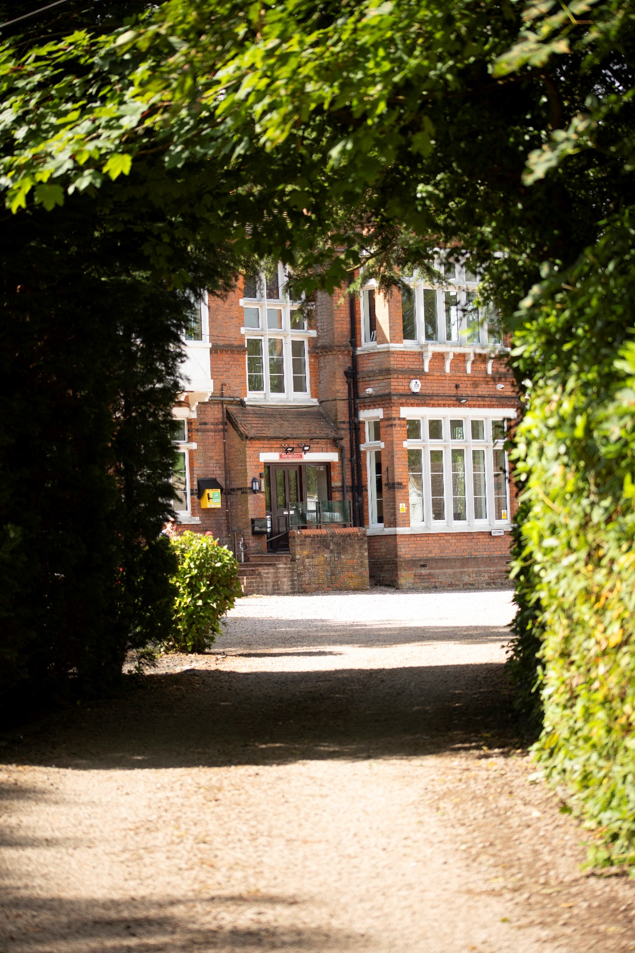

April 2025

Burstow Park School Newsletter

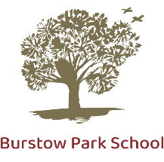
Message from the Head Teacher


Have you ‘Liked’ our Facebook page yet?!
Each week, we post updates about what is going on in school that day / week. It’s a great way to find out about school life, and also for ad hoc reminders. If you would like to give us a follow, find us here!

Dear Parents, Carers and Friends of Burstow Park School, as the 2025 Spring Term comes to an end, we can reflect on a term where we have had many successful transitions of new students, as well as numerous success of existing students. We have had our highest number of students from our Blended Learning Centre move across to main school, and we have welcomed new students into both our sites.

This term saw some timetable changes, primarily with an adjustment to our tutor times in the morning and afternoon sessions. Morning tutor time has been extended to allow for additional support for all students as they transition into their school day – enabling them to be fully prepared and ready for their day of learning. We have also embedded our Social Communication teaching into these tutor times, and we have already seen positive impacts on both productivity and progress as a result of this adjustment.

Our new ‘POINTS’ system has further motivated many of our learners to engage even more effectively in their learning. At Burstow Park School, POINTS really do mean prizes! At the end of each half term, prizes are awarded based on how many points your child has accrued across their lessons. Your child will be keen to tell you what prize they’ve been allocated, I am sure!

The Easter break is an opportunity for students and staff to refresh and look ahead to the summer term. We look forward to welcoming students back to school on 23rd April.

With very best wishes to you all,

Mr. Padfield

Reminders

Term dates
School closes for the spring term on Friday 04 April at 1pm
School reopens for the summer term Wednesday 23 April at 9am (Tuesday 22nd April is staff INSET)

Stationery
All students should attend school with basic stationery they will need for the school day. Specialist equipment is provided as required, however as a minimum, students should arrive at school equipped with a handwriting pen, pencil (inc. colouring pencils/pens), a ruler, eraser.

School Uniform
Please ensure that you send your child to school wearing the correct uniform. Students who arrive at school not in correct school uniform will be returned home immediately. Please refer to the website for our school uniform policy.

Hats, caps, balaclavas, are not permitted in school. Sunhats may be worn outside in sunnier weather.

Please remember to provide your child with a water bottle, which can be re-filled at school.

Absence Reporting – It is vital that you let the school know if your child will not be attending school that day. You can do this by either ringing the school office or by email. Absences must be reported by 9.30am and you must contact the school every day that your child will be absent. Please do not forget.

Website: Burstow Park School - Home
To contact us for any reason, please use any of the methods below.
Telephone: 01293 226940, available between 8.00am – 3.30pm (If calling outside this time, you can leave a voicemail).
Email: bps@burstowparkschool.org
Write to us at: Burstow Park School, Antlands Lane, Shipley Bridge, Surrey, RH6 9TF

¯¯¯¯¯

ASH CLASS

This term, Ash class have been in full swing gearing up for their final exams.
Whilst apprehensive, they have not shied away from asking questions and making sure they know precisely what is required of them. Having taken part in the mocks to the best of their abilities – and having done superbly – students have concentrated on key areas of revision: time management, language and structure features, and paragraph development. As well as this, this term they have been working on their social communications curriculum, designing posters and worksheets around the motif ‘Be Kind’ and what students should do if they feel they need help. Finally, as many of Ash group will be moving on to college, we have spent a lot of time exploring colleges, both for interesting and engaging courses alongside travel options and routes.

ELM CLASS

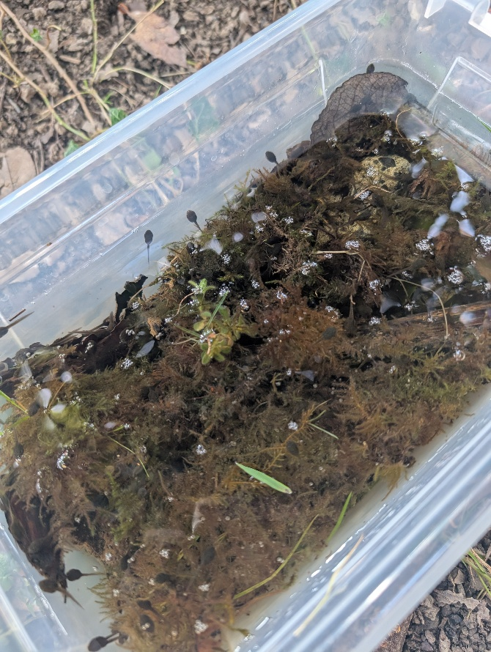
Elm class have settled into the term well work productively together as a group. We had some unexpected guests in our class - the students found some frogs spawn in the field, and we collected a few! We created a place for them to live and they have since broken out of their eggs and are starting to make the transition from tadpoles to froglets. Whilst they haven’t grown their legs yet, they are now starting to become visible. The students have been captivated by these and have been a great talking point during tutor time. The students have taken responsibility for making sure the water is topped up and making sure there is things for the tadpoles to eat. This has been good for team building and talking point for the group.

CEDAR CLASS

Cedar class have been getting very creative this term. They have celebrated world book day by making their own book worms which they took on an adventure around the school grounds. They have also made their own emotional toolkit as part of the social communications curriculum - these are taken with the students to lessons to help with emotional regulation. Lastly, they have
been making some crafts to take home for Mother’s Day. Cedar students have also been working hard on their spellings this term and have been successful at completing this during the morning tutor time.

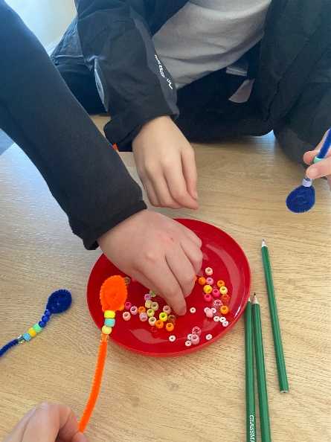
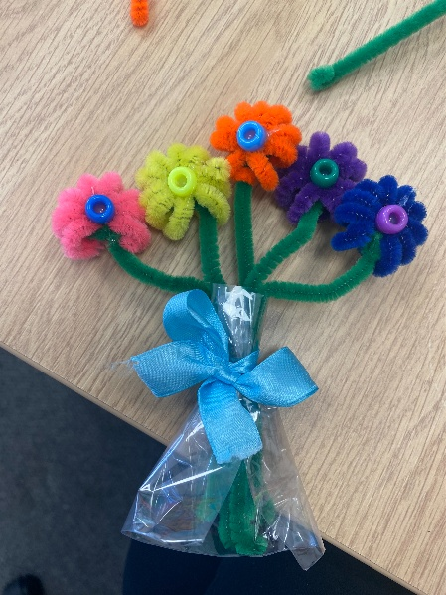

A focus on: ART

GCSE students are preparing their portfolios for marking and are currently working on Photography skills. Here is some of their current work that is on display in the art room.
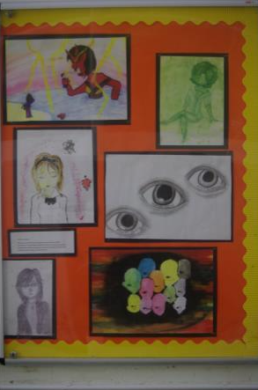

The younger students have worked hard with 3D modelling, and we have some great clay and Modroc pieces being made. Some have also been making puppets, including this amazing articulated dragon.

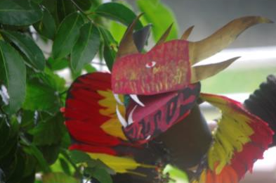

BLENDED LEARNING CENTRE

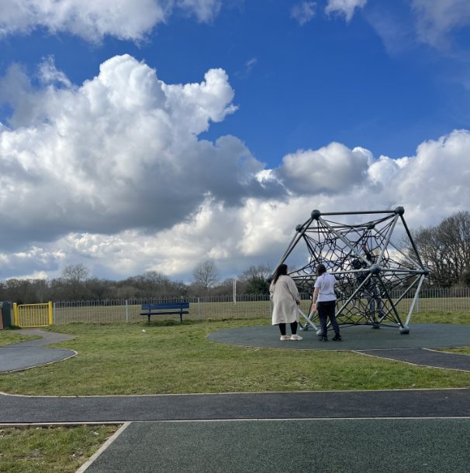
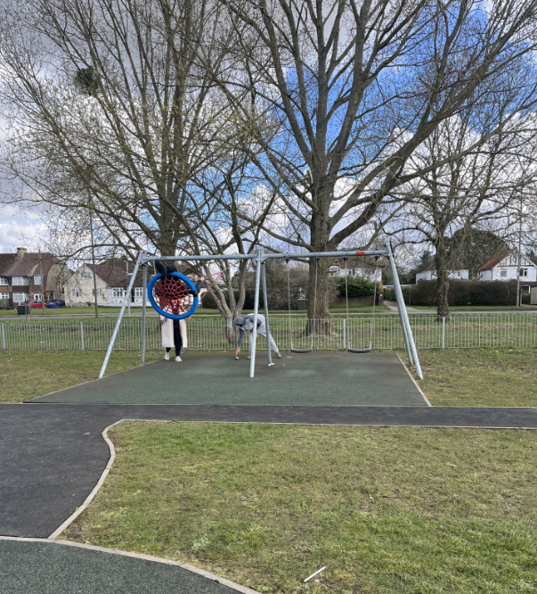
Our Blended Learning Centre students had a fantastic time at the park on their sensory walk this term. They explored nature through sight, sound, touch, and smell—engaging all their senses in a peaceful outdoor setting. Some students from the Blended Learning Centre are now taking an exciting step forward as they transition into the main school setting, building confidence and embracing new learning opportunities. We wish them the best of luck as they embark on this exciting new journey.



